Experiment 7
Continuous-Time Fourier Transform and Spectrum

Objective 1: Analysis of Continuous-Time Fourier Transform of Different Signals
CODE :
clc; clear; close all;
t = -5:0.001:5;
dt = t(2)-t(1);
signals = {exp(-abs(t)), exp(-t.^2), double(abs(t)<=1)};
names = {'e^{-abs(t)}','Gaussian Pulse','Rectangular Pulse'};
for k = 1:3
x = signals{k};
N = 2^nextpow2(length(x));
X = fftshift(fft(x,N))*dt;
f = (-N/2:N/2-1)/(N*dt);
figure;
subplot(2,1,1);
plot(t,x,'LineWidth',1.1);
grid on;
xlabel('Time (s)');
ylabel('Amplitude');
title(['Signal: ',names{k}]);
subplot(2,1,2);
plot(f,abs(X));
grid on;
xlim([-5 5]);
xlabel('Frequency (Hz)');
ylabel('|X(f)|');
title(['Magnitude Spectrum: ',names{k}]);
end

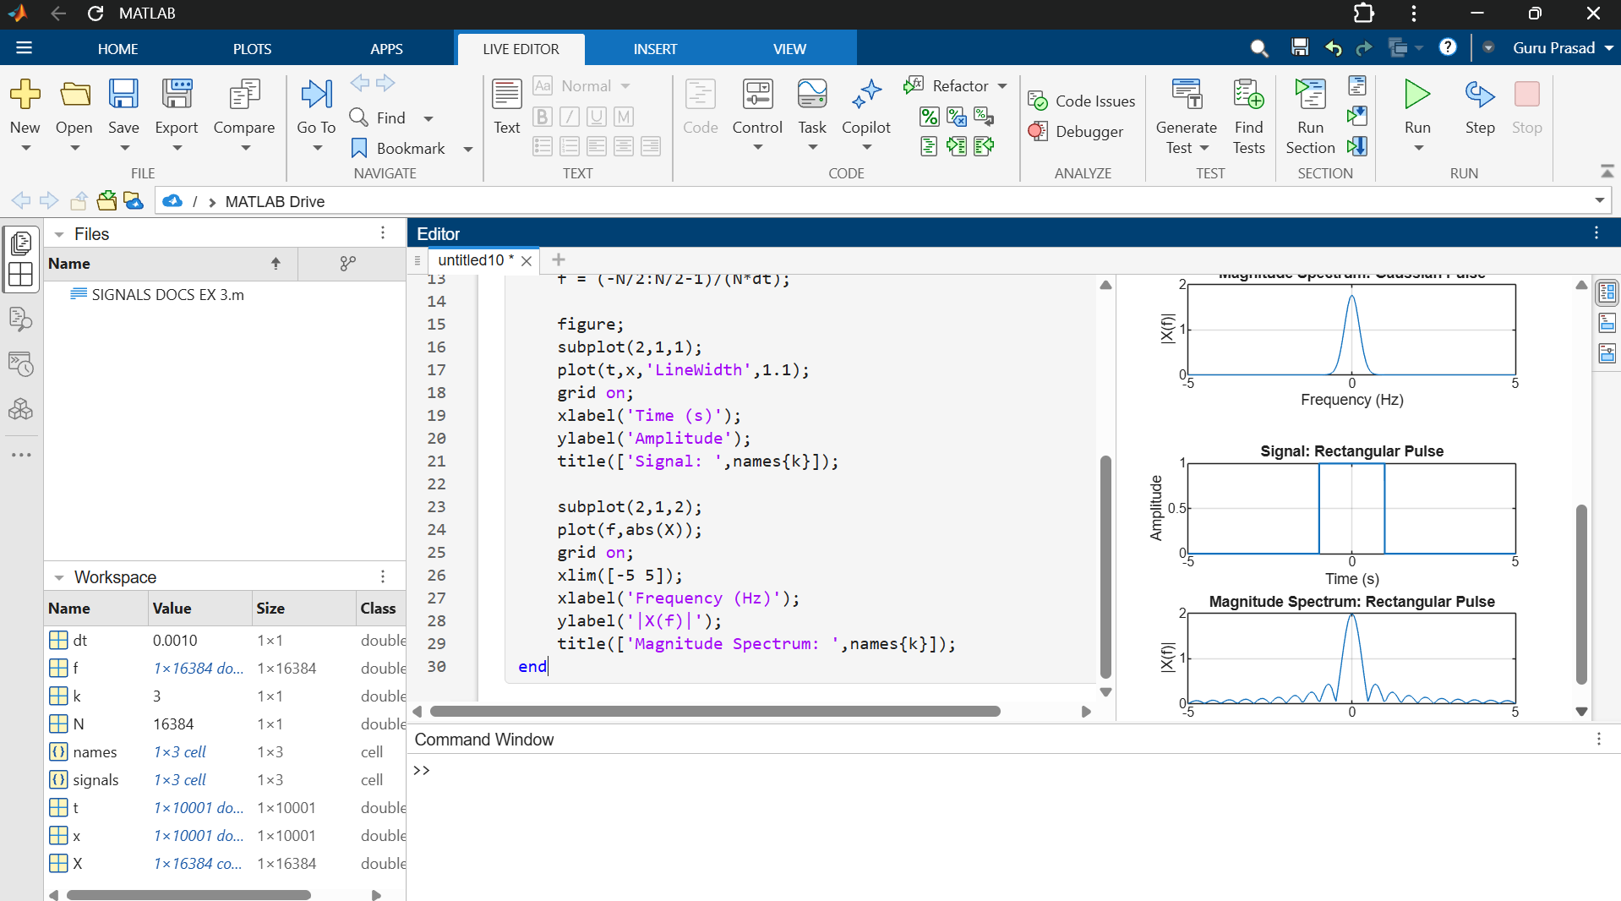
Objective 2: Determination of Magnitude and Phase Spectra
CODE :
clc; clear; close all;
t = -2:0.001:2;
dt = t(2)-t(1);
x = exp(-t.^2).*cos(2*pi*3*t);
N = 4096;
X = fftshift(fft(x,N))*dt;
f = (-N/2:N/2-1)/(N*dt);
magX = abs(X);
phaseX = unwrap(angle(X))
figure;
subplot(3,1,1);
plot(t,x);
grid on;
xlabel('Time (s)');
ylabel('Amplitude');
title('Continuous-Time Signal');
subplot(3,1,2);
plot(f,magX);
xlim([-10 10]);
grid on;
xlabel('Frequency (Hz)');
ylabel('|X(f)|');
title('Magnitude Spectrum');
subplot(3,1,3);
plot(f,phaseX);
xlim([-10 10]);
grid on;
xlabel('Frequency (Hz)');
ylabel('Phase (rad)');
title('Phase Spectrum');

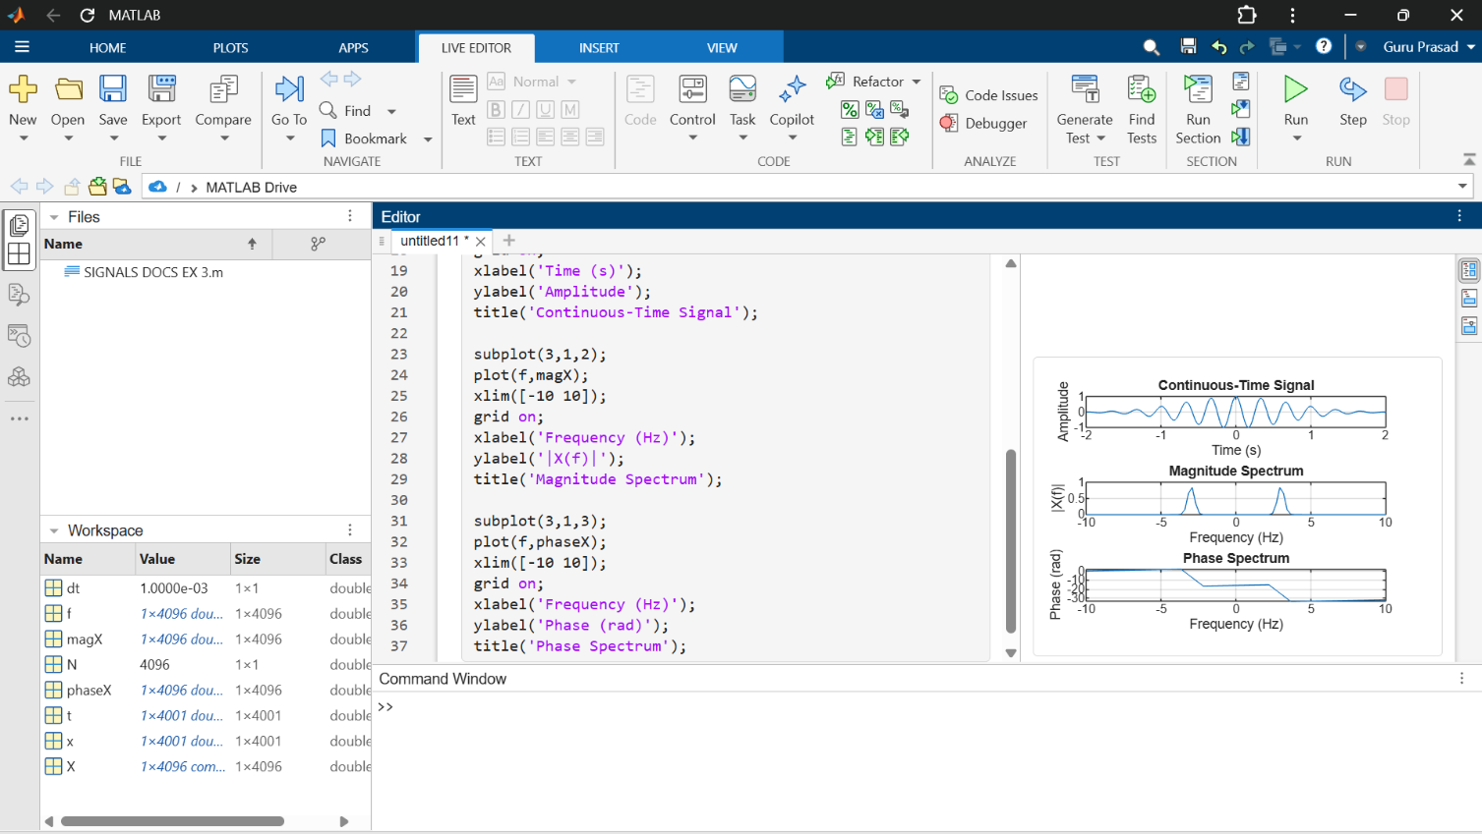

Objective 3: Verification of Fourier Transform Properties
CODE :
clc; clear; close all;
t = -2:0.001:2;
dt = t(2)-t(1);
x = exp(-t.^2);
x_shift = interp1(t,x,t-0.4,'linear',0);
X = fftshift(fft(x))*dt;
N = length(x);
f = (-N/2:N/2-1)/(N*dt);
% Time-shift property
X_shift_theory = X.*exp(-1j*2*pi*f*0.4);
X_shift = fftshift(fft(x_shift))*dt;
figure;
subplot(2,1,1);
plot(f,abs(X_shift),f,abs(X_shift_theory),'--');
xlim([-5 5]);
grid on;
xlabel('Frequency (Hz)');
ylabel('Magnitude');
title('Time-Shift Property: Magnitude Comparison');
legend('Computed','Theoretical');
subplot(2,1,2);
plot(f,unwrap(angle(X_shift)), ...
f,unwrap(angle(X_shift_theory)),'--');
xlim([-5 5]);
grid on;
xlabel('Frequency (Hz)');
ylabel('Phase (rad)');
title('Time-Shift Property: Phase Comparison');
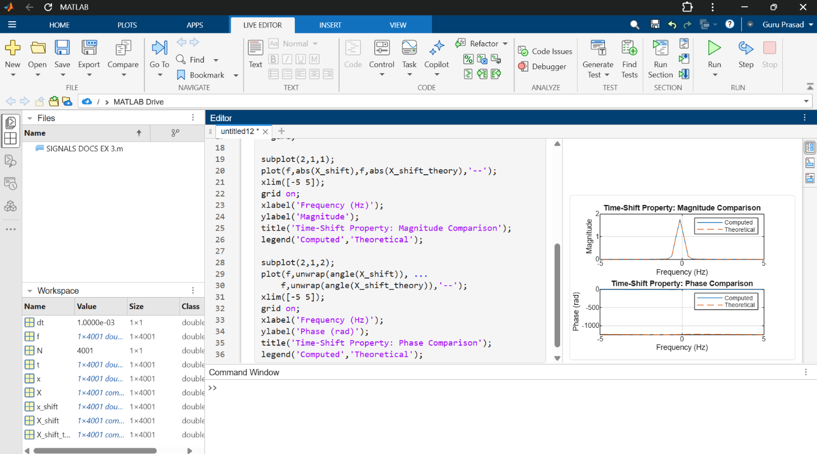
legend('Computed','Theoretical');

Objective 4: Analysis of Signal Bandwidth and Spectral Components
CODE :
clc; clear; close all;
fs = 2000;
t = 0:1/fs:1-1/fs;
% Baseband signal
x = cos(2*pi*50*t) ...
+ 0.6*cos(2*pi*120*t) ...
+ 0.3*cos(2*pi*250*t);
N = length(x);
X = fftshift(fft(x))/N;
f = (-N/2:N/2-1)*(fs/N);
M = abs(X);
figure;
plot(f,M);
grid on;
xlim([-400 400]);
xlabel('Frequency (Hz)');
ylabel('Magnitude');
title('Frequency Spectrum and Spectral Components');
threshold = 0.05*max(M);
idx = find(M >= threshold);
bandwidth = max(abs(f(idx)));
fprintf('Approximate one-sided occupied bandwidth = %.2f Hz\n',bandwidth);

